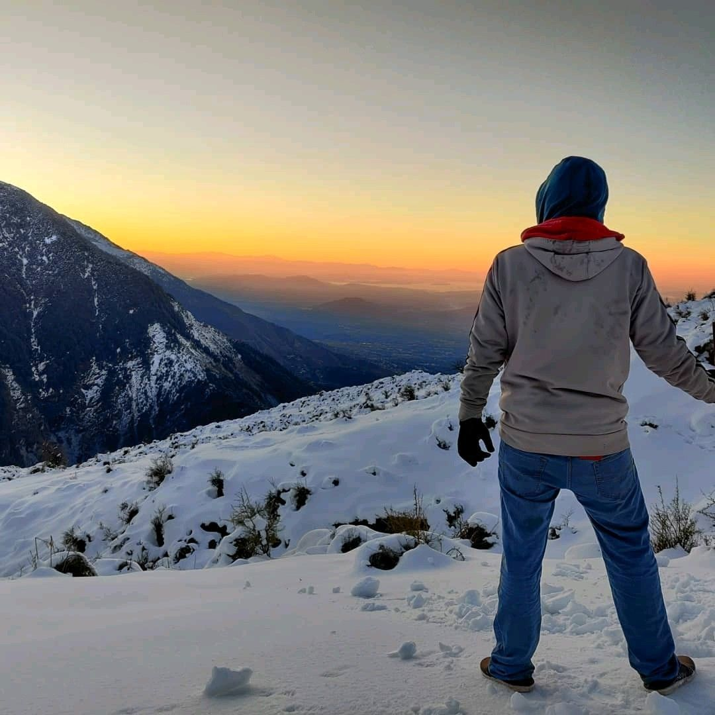
I don't believe in the Mental Health Day.

As much as it has helped promote the discourse around the topic- I don't want it to become like the women's day celebration with office cooking competitions.

I don't want to celebrate it because I still don't know what to tell my best friend when she says she doesn't believe in therapy.

I don't know what to tell people who themselves get lost in their routines and put up stories writing " I wished you tried calling once" when they lose someone.

I don't know how to explain to my brother how watching Jab We Met does not "fix" depression, and how every other new fad/aesthetic is not "therapy"

I don't know how to tell the Psych education system in India to stop being so individual-oriented in training when our identity here itself is embedded in family and culture.

I don't know how to tell psychologists to not get so disheartened when people do not turn up for the sessions because of the above-mentioned reasons.

I also know that every person I talked about above wants to help; and also seek help when needed- and we have come a long way, establishing that something such as "mental health" exists.

But there's a much longer way to go.

The way we see therapy; therapeutic settings; and advocacy- along with how we get taught as professionals- all have to be revamped.

Yes CBT works, but people prefer Astrologists.

There are two ways to look at it-

1. "People here are stupid and only my training which is based in science, research and supervised closed therapeutic safe spaces can help people"

which quickly escalates to

"I think I need to leave the country to get paid; and be respected the way I deserve"

or,

2. "What makes them go see an astrologer? how does it help them? does it have a lower social barrier to access? is it easier to explain? does it appeal more to their identity?- how can we now redesign therapy that suits people here on a mass scale? "

We have to go beyond our conditioning and how we see therapy and mental health as a system.

DBT is amazing; REBT could be cool, CBT has fantastic results- even NLP has some subjective reported benefits (I still don't believe in it), but all of these are tools.

You cannot just buy a hammer and say I've built a city.

Mental health is a state of being- across time and geographies. It is all-pervasive.

A doctor can treat cancer but reducing the biotoxin magnification effect right from how farmers operate will have much widespread effects.

Look at Mental health similarly.

We need everyone on-board.

Are you?

